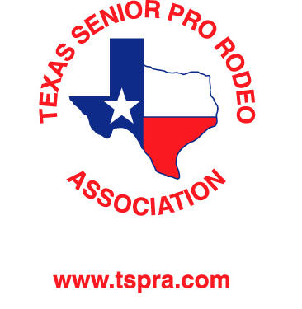

Year-End Awards

TSPRA Finals Rodeo Sponsor – Jacket Sponsor; Saddle Sponsor, $5000.00
Reserve Award & Finals Buckle; Recognition in newsletter, at rodeos, at awards ceremony and on website page

Champion Saddle Sponsor – Jacket Sponsor; Saddle Sponsor $3000.00
Recognition in newsletter, at rodeos, at awards ceremony and on website page

Jacket Sponsor: Logo on Jacket; In Newsletter and on Website $2000.00

Reserve Champion Year End Award Sponsor $ 200.00
Recognition in newsletter, at rodeos, at awards ceremony and on website page

Finals Average Champion Buckle Sponsor $ 175.00
Recognition in newsletter, at rodeos, at awards ceremony and on website page

Prize Sponsor for year-end places 3rd through 10th cash or prizes
(such as breast collars, bits, splint boots, etc.)
Recognition in newsletter, at rodeos, at awards ceremony and TSPRA website

Other Sponsor (amount of your choice) $ ______
Recognition in newsletter, at rodeos, at awards ceremony and TSPRA website

Tiedown Shoot-Out Sponsor $1500.00
Shoot-out will be named after sponsor
Recognition in newsletter, at rodeos, at awards ceremony and TSPRA website

President
Seth Smithson

Vice-President
Tomm Owens

Secretary/Treasurer
Christine Filer

Rodeo Secretary
Beverly Shoaf
P O Box 681
Gatesville, Texas 76528
254-223-2290

2023 Directors

Barrel Racing
Billie Bright
Kay Boyles

Calf Roping
Travis Evans
Dave Laster

Team Roping
Casey Gattis
John Rosanky

Ribbons
Connie Clute

The Officers, Board of Directors and Members of the
Texas Senior Pro Rodeo Association

Heartily Invite Your Participation, Endorsement and Support

2023 TSPRA Sponsorship Opportunities

TSPRA: My organization accepts / I accept your invitation to be a (an) sponsor for 2023.

Enclosed please find our check for $ ________ and/or prizes of equivalent value.

If a Buckle, Saddle or Event Sponsor, the event I would like to sponsor is .

PLEASE PRINT OR TYPE: Name of Individual or Company

Address City State Zip Phone #

EVENTS

40,50, 60, 70 Barrels
40,50,60,65,70,75 Tie Down
40,50,60,70, 80 Breakaway
Ladies Breakaway

Ribbons

40+ Team Roping
60+ Team Roping
70+ Team Roping

Signature

Please return your contribution with this completed form to:
Texas Senior Professional Rodeo
P. O. Box 681
Gatesville, Texas 76528

